***PAAREES PERFUMES***

***VERSACE***

***FOR UNISEX***

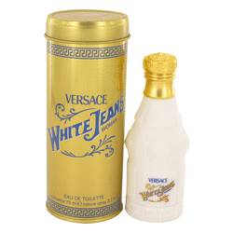

# 

# *White Jeans*

## *Description:*

White Jeans by Versace Perfume. Slip into luxury with White Jeans, a Versace fragrance for women with discerning tastes in fashion. This heady fragrance was created in 1997 with leading notes of cinnamon and various other spices. Subtle notes of carnation, sandalwood and vanilla give this elegant fragrance a certain softness that is versatile enough to wear at work yet glamorous enough to take out on the town. Now you can take the bold style statement of White Jeans and apply it to your fragrance collection.